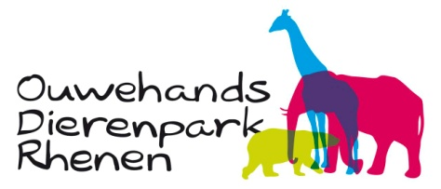

Workbook

5th and 6th Grade

CLIMATE CHANGE

Not only polar bears are feeling the heat...



DO YOU KNOW WHAT

CARBON DIOXIDE AND

GREENHOUSE EFFECT MEAN?

NOT COMPLETELY SURE?

.  
DON'T WORRY!

.  
THIS WORKBOOK WILL TEACH YOU EVERYTHING YOU NEED TO KNOW ABOUT

CLIMATE CHANGE!

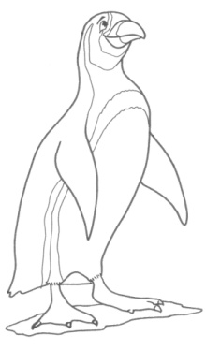

This workbook belongs to:

………………………………………………………………………..……

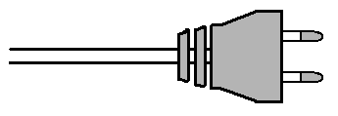

Contents

1. Introduction page 3
2. Arctic and Antarctic page 6
3. Polar animals page 10
4. Greenhouse effect page 16
5. Consequences page 19
6. Action! page 23



HAVE FUN!

 INTRODUCTION

These days we frequently hear in the news that the earth is warming up, weather conditions are becoming more extreme and that the ice caps are melting. The world is transforming because the climate is changing rapidly. Why? Mostly due to the large amount of electricity and fossil fuels we are using.

C:\Users\Imke\AppData\Local\Microsoft\Windows\Temporary Internet Files\Content.IE5\59WKL69V\MC900053962[1].wmf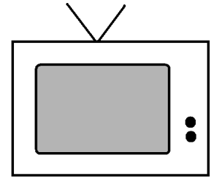.

Question 1

a. How many electronic devices do you have?

Write down as many as you can think of:

|  |  |  |
| --- | --- | --- |
|  |  |  |
|  |  |  |
|  |  |  |
|  |  |  |
|  |  |  |
|  |  |  |
|  |  |  |
|  |  |  |

b. Work together with the person sitting next to you. Did one of you forget any devices? Write them down.

c. Do you ever travel anywhere by car even though you could just as easily get there by bike?

…………………………………………………………………….…….…

……………………………………………………………………………..

POLE TO POLE CAMPAIGN

The leading zoos and aquariums of Europe, through the European Association of Zoos and Aquaria (EAZA) will together with Arctic Action Teams (AAT) and other partners raise awareness and stimulate behavioural change for the conservation of the biodiversity of the two Poles. This campaign is about the two poles; the wonderfully varied species living there and the threats that each face. This campaign focuses on everyone and how small changes in each of our behaviours can help the polar species continue to flourish.

C:\Users\Imke\AppData\Local\Microsoft\Windows\Temporary Internet Files\Content.IE5\59WKL69V\MC900053962[1].wmf

Question 2

a. Look at the electronic devices you have written down on the previous page. Are there any devices that you could easily live without? Draw a cross in the appropriate boxes next to those devices on the previous page.

b. How many electronic devices have you deleted?

I have deleted …………………… electronic devices.

Climate change is felt more acutely in the Polar regions than anywhere else on the planet. Sea ice is melting rapidly and polar animals that depend on the ice are getting into trouble as a result. Take the polar bear for example. The ice that the bears need to hunt on is shrinking, and although polar bears are marvellous swimmers; even they have trouble covering the increasing open water distances between land and the ice sheets without drowning. Scientists predict that if nothing is done to change this, polar bears will become extinct within 50 years.

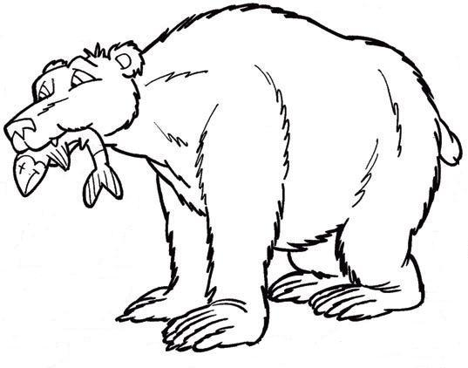

Luckily we can help the polar bear by making small changes to our behaviour. For example: Turning off the lights when you leave a room, lowering the thermostat by one degree and pulling the plug after using an electronic device all help to save energy!

Did you know ?

An amount of electricity is expressed in

‘kilowatt hours’ (kWh).

A fridge uses around 300 kWh of electricity a year.

C:\Users\Imke\AppData\Local\Microsoft\Windows\Temporary Internet Files\Content.IE5\59WKL69V\MC900053962[1].wmf

Question 3

Read the 'did you know' above. At this moment one kWh costs €0,23. Calculate how much it would cost to use a fridge for a whole year. Write down your calculation below:

……………………………………………………………………………

……………………………………………………………………………

……………………………………………………………………………

……………………………………………………………………………

Robert Buchanan, founder of 'Arctic Action Teams’

"We can be the heroes of future generations! We have inherited an amazing world and it's up to us to keep it pristine for the generations to come. Our actions now will determine the future of the planet, and everything that lives on it."

Dr. Ian Stirling, one of the world's leading experts on polar wildlife

"The poles are an indicator of the health of the planet. When we see the huge reductions in the ice covering the poles, and the effect that that this has had on species that live there, we can get an insight into the danger facing the entire world.”

 ARCTIC AND ANTARCTIC

WHERE ARE THE POLAR REGIONS?

North pole

The Arctic is a polar region located at the northernmost part of the earth. The Arctic consists of a vast ice-covered ocean surrounded by treeless permafrost. This is sea ice and a submarine would be able to cruise under the ice! The Arctic includes parts of Canada, the United States, Greenland, Norway, Sweden, Finland and Russia.

The Arctic sea ice melts in the summer and grows back in the winter. So the Arctic actually 'shrinks' and 'grows' ! This may come as a surprise to you, but the Arctic is inhabited by around four million people. Many of them live in the tundra. A tundra is the treeless area bordering the Arctic region.

Arctic

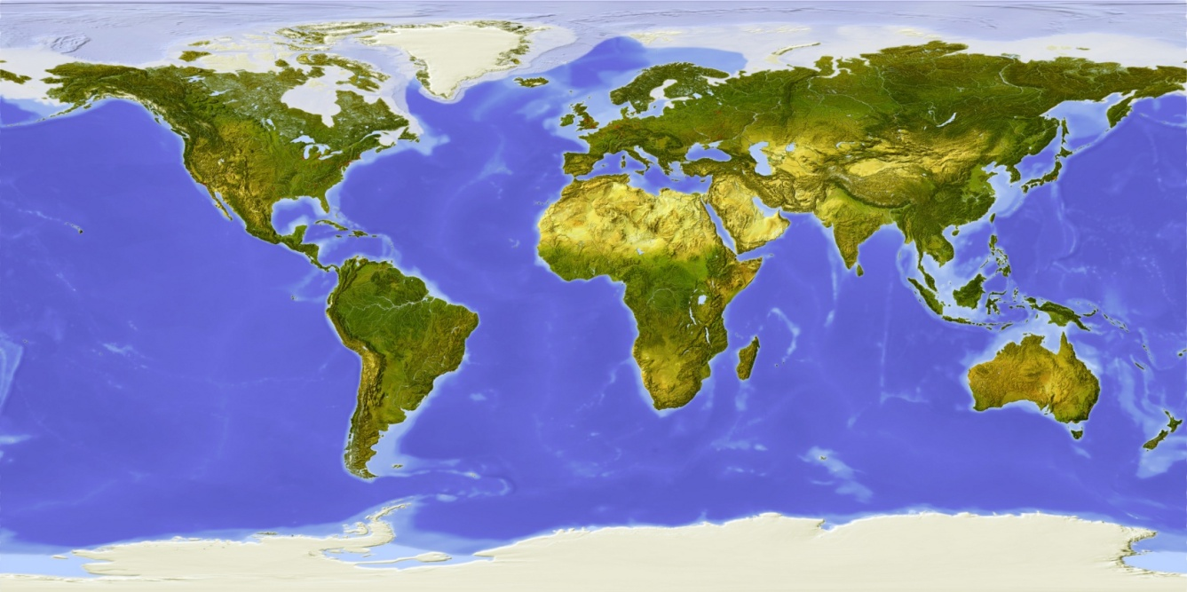

Antarctica

C:\Users\Imke\AppData\Local\Microsoft\Windows\Temporary Internet Files\Content.IE5\59WKL69V\MC900053962[1].wmfQuestion 4

Look carefully at the map on the previous page.

a. Where do you live? Draw a circle around it.

b. Draw a circle around Africa.

c. Draw a circle around Australia.

South Pole

Antarctica is a continent that covers the earth's South Pole. Antarctica is the coldest place on earth. The lowest temperature ever recorded was -89.2˚C!

About 97% of the continent of Antarctica is covered with permanent ice and holds the world's largest amount of fresh water. Antarctica is also very windy!

It is too cold for people to live in Antarctica permanently. Scientists live there temporarily to carry out research, They would like to find out how the changes in the earth's climate impact Antarctica's ice sheets. There is still a lot for them to discover!

  
Did you know?

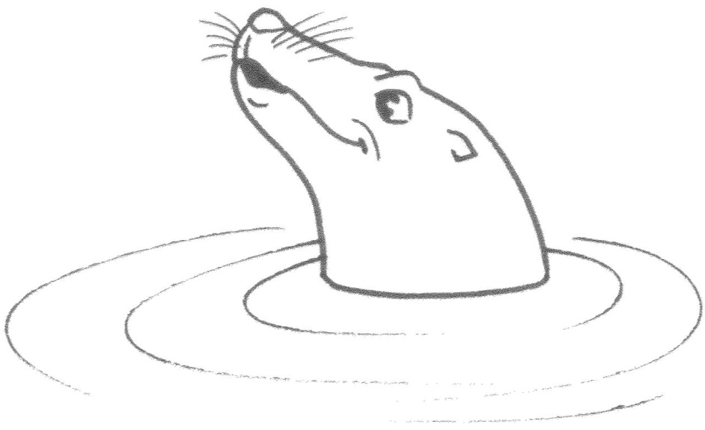Antarctica means ‘opposite of Arctic’.

COMPARING THE POLES

The North and South Pole are very similar, mostly because of the snow and the cold climate. However, there are some big differences between both polar regions.

.

C:\Users\Imke\AppData\Local\Microsoft\Windows\Temporary Internet Files\Content.IE5\59WKL69V\MC900053962[1].wmfQuestion 5

Which text blocks relate to the Arctic and which ones to the Antarctic? Write down the numbers in the table below.

1. Continent surrounded by sea

5. No land mammals

3. Average temperature -18˚C

7. Frozen ocean surrounded by continents





8. Average temperature -50˚C

4. Only temporarily inhabited by researchers

2. Different species of land mammals

6. Around four million inhabitants



|  |  |
| --- | --- |
| NORTH POLE | SOUTH POLE |
|  |  |
|  |  |
|  |  |
|  |  |



WHY ARE THE POLES SO COLD?

Brrrr!

The sun radiates heat towards the earth. Still, it is freezing cold at the poles. How is this possible? This is because the sun shines at a very oblique angle at the poles. This can be demonstrated with a torch. When you shine a torch directly onto a wall one area will become very bright. When you shine a torch at an angle you will notice a larger area which is less bright. The light is dispersed over a larger area. The poles therefore receive very little heat from the sun. The ice is actually not helping either as it reflects the heat from the sun directly back into space.

Light and dark

The Arctic and Antarctic winter is a horror. It is freezing cold and… dark! At the most northern part of the North Pole the sun sets in September and only rises again in March! Then it shines for six months straight. Not easy to deal with! These phenomena are called the polar night and the midnight sun. The same thing happens at the most southern part of the Antarctic, but in reverse.

C:\Users\Imke\AppData\Local\Microsoft\Windows\Temporary Internet Files\Content.IE5\59WKL69V\MC900053962[1].wmfQuestion 6

Where would you rather live? In the Arctic or the Antarctic region?

I would rather live in the …….……………..……..........., because

………………………………………….…………………………………..…….

…………………………................…………………………………………..…

Did you know?

There are actually two North Poles:

the geographic North Pole and the magnetic North Pole. The geographic pole is what you have been reading about in this workbook. A compass needle points to the magnetic North Pole.

 POLAR ANIMALS

The freezing cold at the poles is not a problem for most of the animals that live there. In fact the snow and ice does not bother polar animals very much at all! They are fully adapted to the cold and harsh weather. Land animals have a thick insulating fur coat whilst birds have very dense feathers. Many animals also have a layer of fat to retain body heat. All these adaptations are necessary to survive at the cold and snowy poles. However, for some animals the poles are too cold in the winter. They go to warmer areas in the winter and return in the spring.

Did you know?

The largest land animal in Antarctica is

a wingless midge!

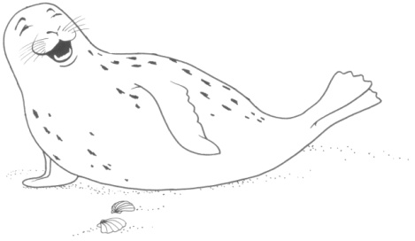

C:\Users\Imke\AppData\Local\Microsoft\Windows\Temporary Internet Files\Content.IE5\59WKL69V\MC900053962[1].wmfQuestion 7

1. Look at the pictures of the different animals on this page and the next. Match each name with the correct picture.

arctic fox, king penguin, polar bear, lemming, reindeer, albatross

1. Do these animals live in the Arctic or the Antarctic?

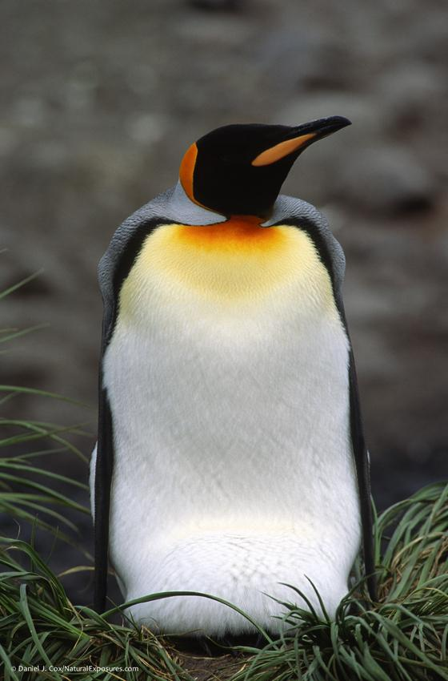

I am a …………………………….……………

I live in the ………………………………….…

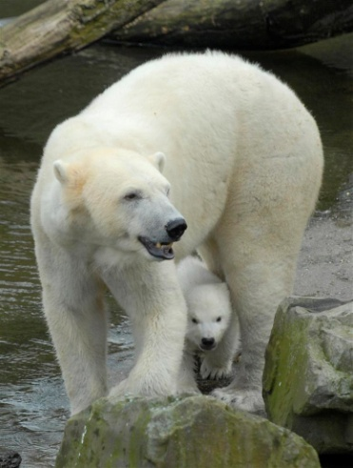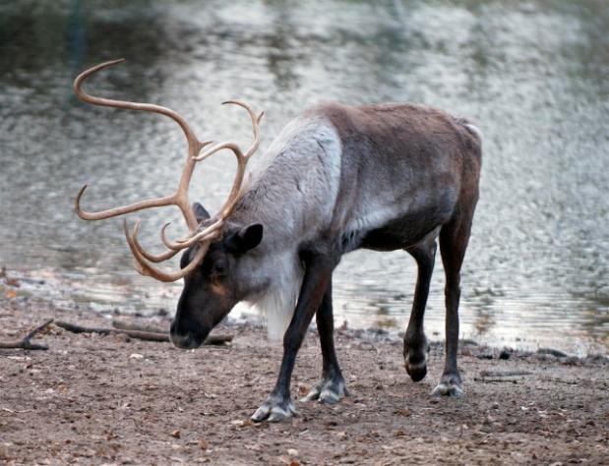

I am a …………………………………………

I live in the ………………………………….…

I am a …………………………………….…

I live in the ………………………………….

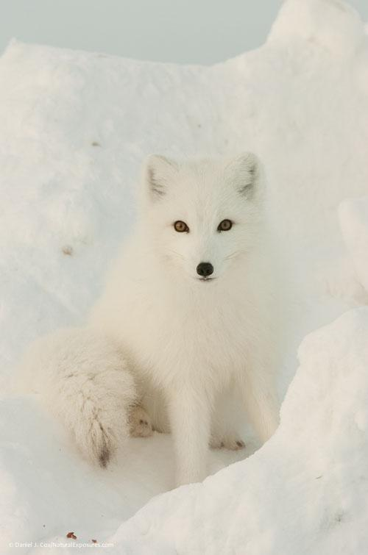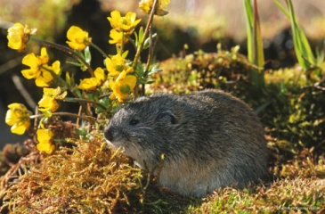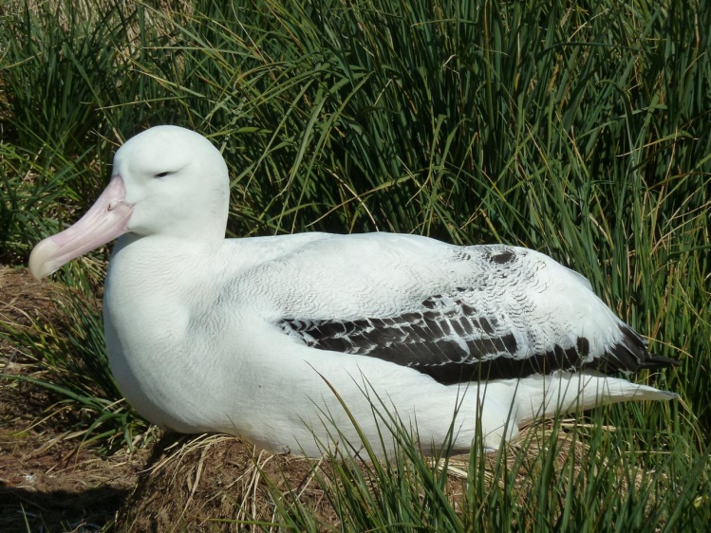POLAR BEAR

I am an ………………………………………

I live in the …………………….………….…

I am an …….…………………………………

I live in the ………………………………...…

I am a ……………………………….…………

I live in the ………………………………….…

When you think of the Arctic you think of the polar bear! He is big and white and looks like a cute teddy bear. Still, you would not want to run into this giant. Luckily that is not going to happen anytime soon since this pole traveller lives in territories where our ears would freeze off. The polar bear has a sturdy and robust build and with its layer of fat and beautiful thick coat the bear is perfectly equipped to survive in a world of snow and ice.

Black bear?

A polar bear is black, at least if you were to remove the fur. Only the nose proves this little secret. The black skin absorbs the heat from the sun. The thick, white fur keeps the heat inside. A polar bear is almost completely covered with fur. Only the nose, paws and lips are hairless. The polar bear has a layer of fat which offers excellent protection against the cold. Sometimes a polar bear's bodyweight may consist half of fat!

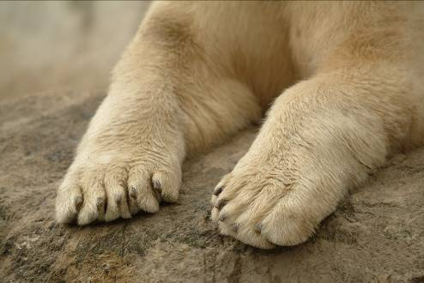Special feet

A polar bear will never slip on the ice thanks to the sharp claws and stiff hairs underneath the feet. The soles are thick and offer protection against the freezing cold. A polar bear has webbed toes and is an excellent swimmer!

Habitat

Polar bears live in the Arctic where they hunt seals at openings in the sea ice, called leads. Polar bears locate these leads with their powerful sense of smell and lie in wait for the seal to surface. When a large part of the ice melts in the summer the polar bear moves to the tundra.



Did you know?

The tongue of a polar bear is purple or dark blue!

C:\Users\Imke\AppData\Local\Microsoft\Windows\Temporary Internet Files\Content.IE5\59WKL69V\MC900053962[1].wmfQuestion 8

Answer the questions below, then write down the letters next to your answers in the table.

1. A polar bear does not slip on the ice thanks to

- webbed toes f

- stiff hairs underneath the feet d

- a robust body t

2. How can you tell a polar bear has black skin?

- the nose is black a

- it shows through the fur o

- A polar bear does not have black skin! d

3. A polar bear lives a solitary lifestyle. What does that mean?

- polar bears live together in groups i

- polar bears live alone n

- polar bears are on a special diet l

4. What is the main prey of the polar bear?

- seals g

- penguins n

- fish t

5. A polar bear is a mammal. What does that mean?

- a polar bear lays eggs a

- a polar bear gives birth to live young e

- a polar bear never mates r

6. Young polar bears are born in

- the bushes t

- the sea n

- a snow den r

Because of climate change polar bears are in

|  |  |  |  |  |  |
| --- | --- | --- | --- | --- | --- |
| 1 | 2 | 3 | 4 | 5 | 6 |
|  |  |  |  |  |  |

KING PENGUIN

When you think of Antarctica you think of the king penguin. The king penguin lives on islands near Antarctica and is very well adapted to the cold and harsh weather.

Submarine

The body of the king penguin is totally adapted to living in the sea. The king penguin has small wings that look like fins and the body is completely streamlined. In fact, the king penguin looks a little bit like a submarine!

Thick coat

The thick feather coat keeps the king penguin warm, even in the ice-cold water. When the feathers wear out, they no longer provide a dense layer and the heat escapes. Luckily, the king penguin grows brand new feathers on a regular basis. The old feathers only fall out when the new ones are all in place. This process is called moulting. The penguin's new feather coat is shiny black and white and will last for about a year.

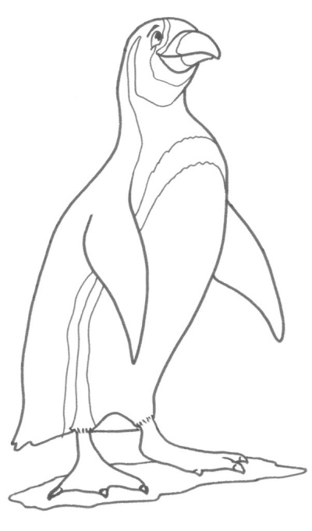  
Useful suit

It looks as if a king penguin is wearing a suit. Although black and white stand out, these are camouflage colours for a penguin. The king penguin is practically invisible to sharks and sea lions because the white belly of the penguin does not show against the reflection of the sun on the water. When flying predators look down onto the water, they only see a dark surface. The penguin's black back makes them nearly invisible! Therefore king penguins wear a very useful suit!



Did you know?

The first people that ever set eyes on a penguin thought they were 'fish with feathers'.



GREENHOUSE EFFECT

Greenhouse effect, carbon dioxide and fossil fuels are words you may have heard quite often. They all have something to do with climate change.

NATURAL GREENHOUSE EFFECT

The earth is the only planet that we know of where plants and animals can live. Our planet is surrounded by a thin layer of gases, the atmosphere. Without this layer of gases life on earth would be impossible. This 'blanket' around the world is formed by greenhouse gasses like carbon dioxide (CO2). The atmosphere retains the heat which in turn keeps the temperature on earth pleasant.

CO2 is released in the air by fires, volcanic eruptions, but also by our respiration. Trees and plants absorb part of the CO2 from the air to make food. This is called photosynthesis. The more trees and plants

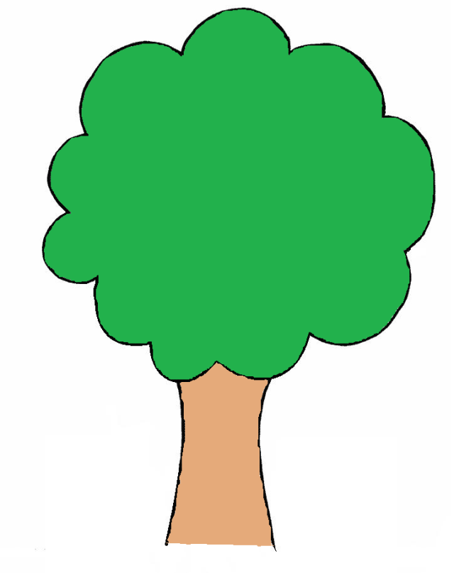there are, the more CO2 is taken away from the air and stored in nature.

A healthy balance!

CO2

CO2

Did you know?

Without the atmosphere the average temperature on earth would be -18˚C. Now it is on average 15˚C.

FOSSIL FUELS

During the industrial revolution 200 years ago people started to use large amounts of fossil fuels. Fossil fuels are coal, oil and natural gas. These are actually fossilized remains of animals and plants and they contain a large amount of CO2.

We are using these fuels as an energy source. Coal gets burned in power plants to generate electricity. Oil is turned into petrol and natural gas is used to heat our houses.

PANIC IN THE ATMOSPHERE

Because people are using so much fossil fuel, CO2 that has been stored in the ground for millions of years is released back into the air in a short amount of time. This upsets the natural balance of the earth. On top of this more and more forests are being cut down. This reduces the natural CO2 storage capacity. The blanket surrounding the earth is getting thicker and thicker and less heat is sent back into space. The heat is locked in and as a result the temperature on earth rises.



heat

CO2

atmosphere

C:\Users\Imke\AppData\Local\Microsoft\Windows\Temporary Internet Files\Content.IE5\59WKL69V\MC900053962[1].wmfQuestion 9

Have you used any fossil fuels today?

……………………………………………………………………………………

……………………………………………………………………………………

Tick the answers that apply to you.

* I went to school by car, train or bus
* I showered with hot water
* I listened to the radio or watched TV
* This morning the central heating was on at home

What are you going to do tonight? Tick the answers that apply to you.

* I am going to eat a hot meal
* I am going to watch TV or play games on the computer or tablet
* I am going to sports practice by car
* I am going to turn on the lights when I get home

Nowadays we use fossil fuels for a lot of things. We even use more fossil fuels than our parents and grandparents did when they were our age. Nowadays almost everybody has a television and a car and children play computer games or listen to music on an MP3-player.



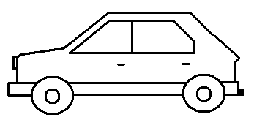

CONSEQUENCES

Climate change is a change in weather patterns and climate over a certain period of time. When we think of climate change, global warming immediately comes to mind. Since 1850 the average temperature on earth has risen by roughly 0.8˚C. Whilst many people would not mind a warmer climate this small temperature rise has a huge impact on nature.

C:\Users\Imke\AppData\Local\Microsoft\Windows\Temporary Internet Files\Content.IE5\59WKL69V\MC900053962[1].wmfQuestion 10

What comes to your mind when you think of climate change?

Write down your thoughts below.

……………………………………

………………………………….

………………………………………

CLIMATE CHANGE

……………………………………

……………………………………

…………………………………..

Did you know?

Even a slight temperature rise can have a dramatic impact on humans, animals and plants anywhere in the world!

MELTING ICE CAPS

The Arctic and Antarctic are extremely vulnerable to global warming. In recent years, significant changes have appeared in the extent and thickness of the permafrost layer. Permafrost is soil that is frozen year-round. Scientists are particularly worried about the large amounts of greenhouse gases that will be released into the air when the permafrost layer thaws.

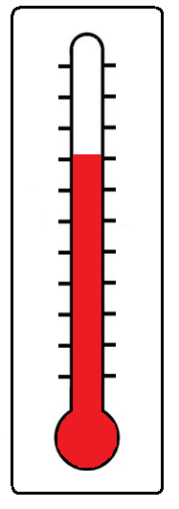SEA LEVEL RISE

Higher temperatures are causing a rise of sea level.

This is because of two reasons.

1. Not only is the permafrost layer thawing because of higher temperatures, also glaciers and ice caps at the Antarctic are getting smaller and smaller. The water from the melting glaciers and ice caps flows into the sea causing the sea level to rise.
2. Another reason for the rising sea level is that water expands when it gets warmer. When the seas get warmer, the water expands and the sea level rises even more.

Low-lying areas can flood when the sea level rises. It costs billions of euros to raise and reinforce the dikes. Mostly developing countries will be affected by this as these countries have no money to improve the dikes.

Did you know?

The sea level will rise by 60 meters if the whole Antarctic ice cap melts! More than 600 million people live in coastal areas which are less than 10 meters above sea level...

C:\Users\Imke\AppData\Local\Microsoft\Windows\Temporary Internet Files\Content.IE5\59WKL69V\MC900053962[1].wmfQuestion 11

Did you read the 'did you know' on the previous page? Do you think the country you live in will flood if the whole Antarctic ice cap melted?

Yes / no, because..…………………………………………………….

…………………………………………………………………………..

………………………………………................................................

EXTREME WEATHER

The weather is also influenced by climate change

and seems to become more and more extreme:

heat waves and heavy storms are just a few examples.

Heavy rainfall can cause floods and extreme heat waves

can cause forest fires. Extreme weather conditions do

not only influence nature, but they also have an impact

on agriculture. Crops can fail because of extreme drought

or heavy rainfall.

ANIMALS IN TROUBLE

Global warming causes many changes. Tundras transform into forests and polar deserts transform back into tundras. Wet periods get wetter and dry periods even drier. Plants and animals try to adapt to the rapidly changing environment. Sadly, often they are not able to adjust quickly enough.

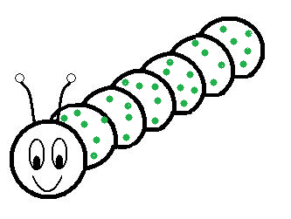We may not be aware of it yet but problems due to global warming are already occurring close to home. For example to birds like the Great Tit. These birds feed their young with caterpillars. Nature is perfectly in balance so the chicks hatch at a time when there are many caterpillars to feed on. However, now that it is getting warmer, the caterpillars appear earlier so by the time the chicks hatch, all the caterpillars have already turned into butterflies…

C:\Users\Imke\AppData\Local\Microsoft\Windows\Temporary Internet Files\Content.IE5\59WKL69V\MC900053962[1].wmfQuestion 12

Climate change also has a significant impact on food chains.

All animals and plants in nature depend on each other. They need each other since one creature is food for another. A food chain shows how each living thing gets food and how nutrients and energy are passed from creature to creature.

a. Who is eating who? Draw arrows between the animals.

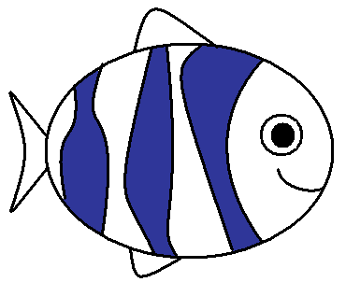

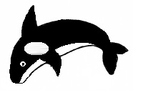



b. Draw a food chain with three other animals or plants.

ACTION!

In this workbook we have learned that climate change is a serious problem. The good news is that there are many ways in which we can help!

And you can help too!

If everybody collaborates we can maybe even solve the problem! Global warming is caused by too many greenhouse gases in the air. We also know what to do in order to reverse this: produce fewer greenhouse gases. There are three ways to accomplish this: by saving energy, planting trees or by using energy-efficient appliances.

[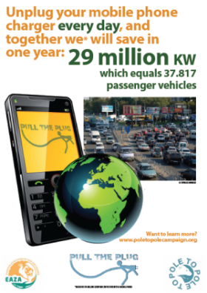](http://www.poletopolecampaign.org/wp-content/uploads/2013/10/infographic_cars.pdf)



1. SAVING ENERGY

Much of our energy use is unnecessary. For example when you forget to turn the lights off when you leave a room or when you leave the television on when nobody is watching. Numerous examples come to mind. If everybody was to avoid unnecessary electricity consumption, we could save a lot of energy. Did you read the infographic on the previous page? If 134 million people unplug their mobile phone charger when the phone is fully charged, we will save a lot of energy!

C:\Users\Imke\AppData\Local\Microsoft\Windows\Temporary Internet Files\Content.IE5\59WKL69V\MC900053962[1].wmfQuestion 13

Do you ever use energy unnecessarily?

Write down four things you can do at home to save energy.

1 ……………………………………….……………………….

2 ………………………………………………………………..

3 ………………………………………………………………..

4 ………………………………………………………………..

Standby

Standby mode is one of the major unnecessary consumers of   
energy. Think about the little red light on your television that remains on when the television is turned off. It does not seem like much, but if left on 24 hours a day, 365 days a year it consumes a significant amount of energy. Unnecessary energy consumers include the television, the computer and the microwave. It is easily remedied, just pull the plug!

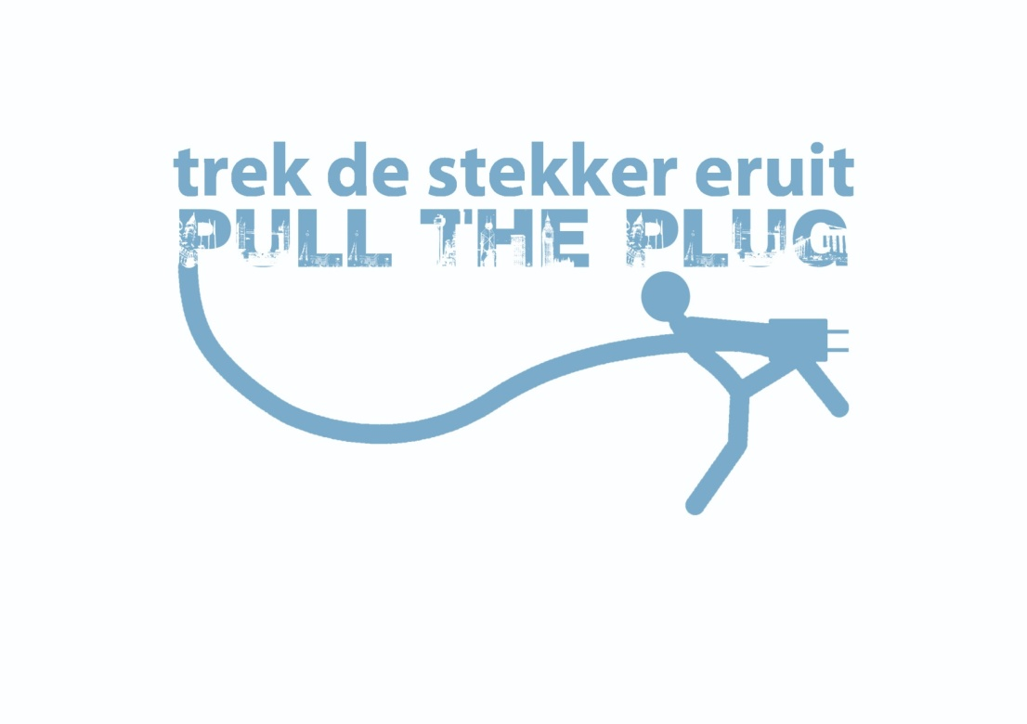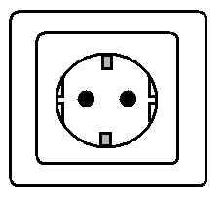

C:\Users\Imke\AppData\Local\Microsoft\Windows\Temporary Internet Files\Content.IE5\59WKL69V\MC900053962[1].wmfQuestion 14

How do you know that these appliances are still using energy despite not being used?

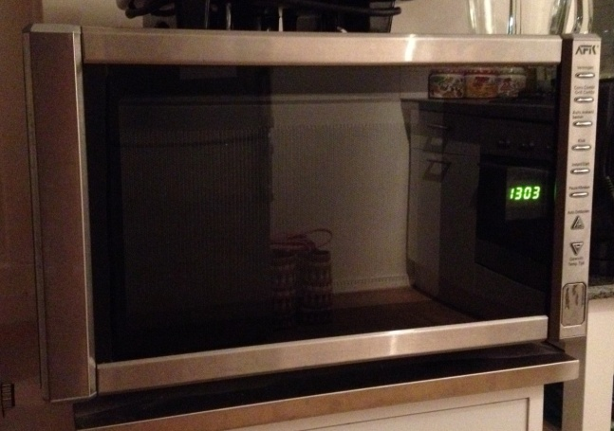

……………, because……………………..…

………………………………………..………

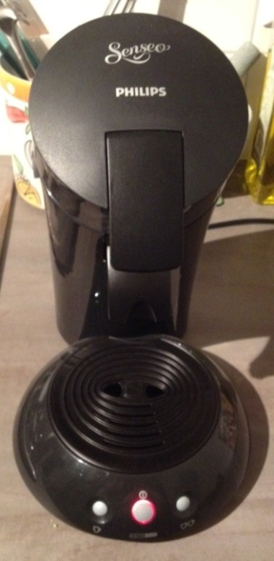

……………, because……………………..…

………………………………………..………

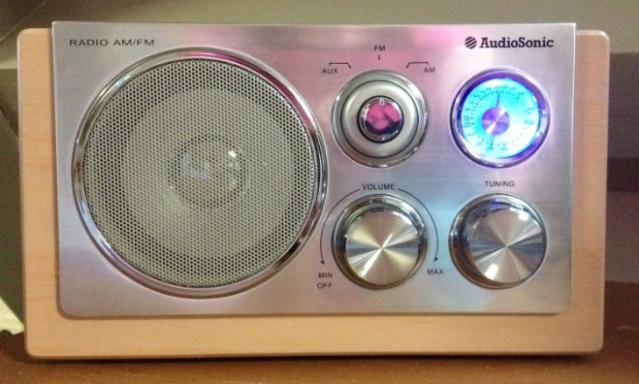

……………, because……………………..…

………………………………………..………

Did you know?

An average European family wastes 6.3% of their total energy use on appliances which remain in standby mode.

C:\Users\Imke\AppData\Local\Microsoft\Windows\Temporary Internet Files\Content.IE5\59WKL69V\MC900053962[1].wmfQuestion 15 (FOR THE REAL GENIUSES!)

.  
Did you read the 'did you know' on the previous page?

If a family uses 2,200 kWh of electricity in a year, how much kWh do they waste because of the standby mode?

Write down your calculation below:

……………………………………………………………………………………

……………………………………………………………………………………

……………………………………………………………………………………

Local products

You can also save energy in a different way. For example by buying local products, like honey from your local beekeeper. This honey does not have to be transported from foreign countries which saves energy!

Less packaging material

Do you ever bring a cookie to school? One that is wrapped in plastic and also in a small cardboard box? It is better to buy products which have less packaging material. The production of those materials requires energy too! Small cartons of juice are not so good either. It is better to bring a plastic bottle that you can refill a couple of times.

C:\Users\Imke\AppData\Local\Microsoft\Windows\Temporary Internet Files\Content.IE5\59WKL69V\MC900053962[1].wmfQuestion 16

Which is the better choice?

To bring your lunch in a plastic bag or in a lunchbox?

……………………………………………………………………………………

……………………………………………………………………………………

Recycling

You can also save energy by recycling. For example, an old glass bottle should be placed in the glass recycling bin and old batteries should be disposed of properly. This way waste products can either be re-used or destroyed safely. Another way to recycle is to have any used things repaired. Is there a hole or a tear in your jeans? Cut them off and make a pair of shorts out of them. And what if your older brother or sister has a nice sweater that does not fit anymore? Maybe you can wear it!

C:\Users\Imke\AppData\Local\Microsoft\Windows\Temporary Internet Files\Content.IE5\59WKL69V\MC900053962[1].wmfQuestion 17

Which bin do you use?

Choose from: glass recycling bin, compostable household waste bin, normal waste bin, paper recycling bin

Potato peels should go into the…….……………………………..……….…..

Newspapers should go into the ……………………………….……..………..

Chewing gum should go into the …………………………………....……….

Glass jars should go into the …………………………………….…………….

A shoebox should go into the ….……………………………………….……..

1. PLANTING TREES

Earlier we learned that trees help fight global warming. Forests provide natural storage for CO2. Sadly, deforestation is a very real environmental threat worldwide. Not only do tigers and gorillas suffer from habitat loss due to destruction and habitat fragmentation, we humans are also affected. Trees store a large amount of CO2. Fewer trees automatically means fewer CO2 storage possibilities. Deforestation is happening at an alarming rate. We lose the equivalent of several dozens of football fields per minute to deforestation.

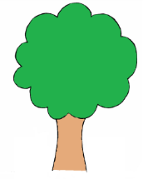



1. USING ENERGY-EFFICIENT APPLIANCES

Not only our country, but a lot of other countries worldwide want to reduce global warming. In order to reduce the emission of greenhouse gases, several countries from the United Nations have come to an agreement. The Kyoto Protocol is an international treaty committed to reducing the emissions of greenhouse gases worldwide. Unfortunately not all countries around the world have signed the treaty.

There are scientists who believe they can stop climate change with the help of inventions. There are some scientists who think that cloud factories are the solution! These scientists claim that they can create clouds which can block the heat from the sun. This will allow the earth to cool down a little bit. Those clouds are formed by spraying seawater into the air. However, nobody knows whether these cloud factories will ever be built…!

C:\Users\Imke\AppData\Local\Microsoft\Windows\Temporary Internet Files\Content.IE5\59WKL69V\MC900053962[1].wmfQuestion 18

Draw a picture of a cloud factory, the way you think it could look.

Fortunately there are also developments that have been apparent for a while now. Many household appliances have become a lot more energy-efficient. A modern washing machine is significantly more energy-efficient than a washing machine manufactured in 1990. Many companies are constantly developing new methods to improve the energy efficiency of many appliances. So it is not all bad news!

C:\Users\Imke\AppData\Local\Microsoft\Windows\Temporary Internet Files\Content.IE5\59WKL69V\MC900053962[1].wmfQuestion 19

Choose two subjects and describe how you would use them to stop climate change.

You can choose from:

Saving energy, planting trees or using energy-efficient appliances.

I am going to .……………………………………………………….………….

……………………………………………………………….…………………..

……………………………………………………………………………………

………………………………………………………………………….………..

……………………………………………………………………………………

I am also going to ....………………………………………….…………………

……………………………………………………………….……………………

…………………………………………………….………………………………

………………………………………………………………………….…………

…………………………………………………….………………………………



Take action!

It is important that as many people as possible start to save energy.

You can help by taking action! Why don't you make some posters on the subject and distribute them in your neighbourhood to raise awareness. Or you can organise an information market. There are a lot of great ideas!

Take a look at the Pole to Pole campaign website:

www.poletopolecampaign.org

Here you can take the pledge and pull the plug!

Together we can make a huge difference!

Good luck with your fight against

climate change!

